Request for New Course Designator

OSU-Cascades is requesting a new **SE** course designator for the proposed BS Software Engineering degree program, currently submitted as draft [Category I proposal 101368](https://secure.oregonstate.edu/ap/cps/proposals/view/101368). We wish to create this course designator now, so that we may submit Category II proposals for new courses to accompany the Category I proposal.

Purpose

* What academic programs, including majors, certificates, options and minors will be served by courses within the designator?

The SE designator serves a new BS Software Engineering program described in [Category I proposal 101368](https://secure.oregonstate.edu/ap/cps/proposals/view/101368). In the future, the program accommodates, by design, future opportunities to support specific “degree options” in software engineering, a software engineering minor, graduate courses in software engineering, and, possibly, a certificate program in software engineering.

* In what ways do the general area and scope of the content constitute a coherent body of knowledge?

Software engineering is a distinct program of study. The area and scope of the content represents the [IEEE Software Engineering Body of Knowledge](https://www.computer.org/web/swebok), a peer-recognized standard for software engineering content.

Software engineering is not computer science, electrical engineering, computer engineering, nor is it management information systems. These are related, but very separate, and well-known disciplines. ABET also maintains different accreditation standards for software engineering compared to computer science.

* Is the proposed usage of the designator consistent with practice at OSU and other institutions? Give examples.

The usage of the SE designator is consistent with other programs, with examples including CS for computer science and EE for electrical engineering. Each program in the OSU College of Engineering has its own designator. The Software Engineering program is accredited by the Engineering Accreditation Commission of ABET and Computer Science by the Computing Accreditation Commission of ABET. Oregon Tech uses CST, based on the CSET Department name, and we believe the CST prefix to be cumbersome for a software engineering program.

Rose-Hulman uses the CSSE prefix for all courses in both the computer science and software engineering curriculum, a combination of CS and SE. This makes sense for Rose-Hulman, and schools that have a significant overlap in required courses for both CS and SE courses. For example:

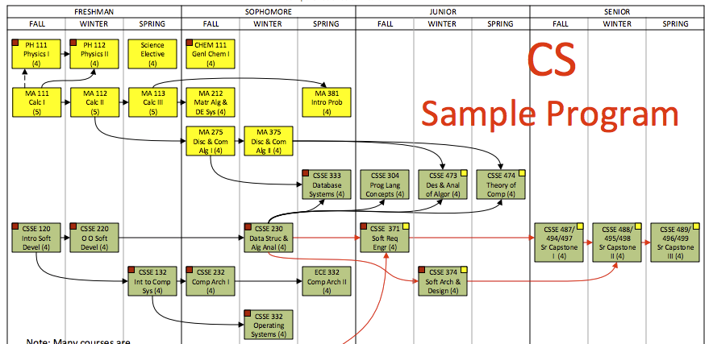

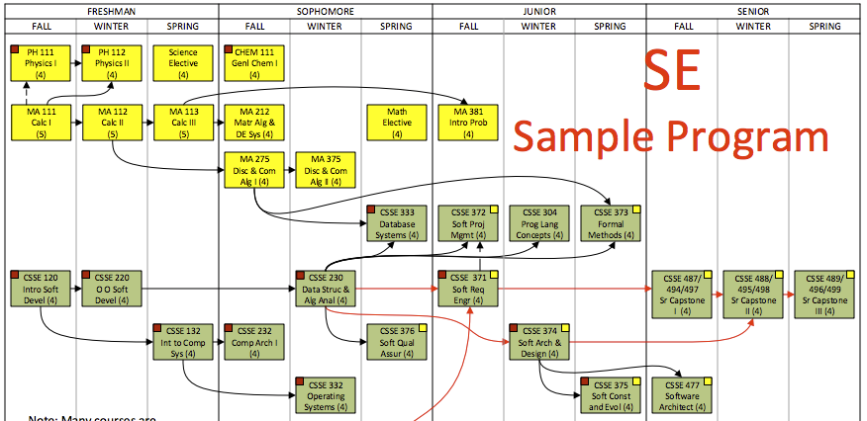

Figure 1. Rose-Hulman CS and SE programs, with a single CSSE designator.

Hold this at arm’s length, and you will see very little difference between the two programs.

* + First-year students take the exact same CSSE courses
  + Second-year students take four of the five exact same CSSE courses
  + Third-year students take three of the five/six exact same CSSE courses
  + Fourth-year students take the same capstone sequence of CSSE courses

Unlike a CSSE program, *the proposed OSU SE program does not have significant overlap with CS*. Using a CSSE prefix for the proposed OSU SE program would be *inconsistent* with practice at OSU and other institutions. For example:

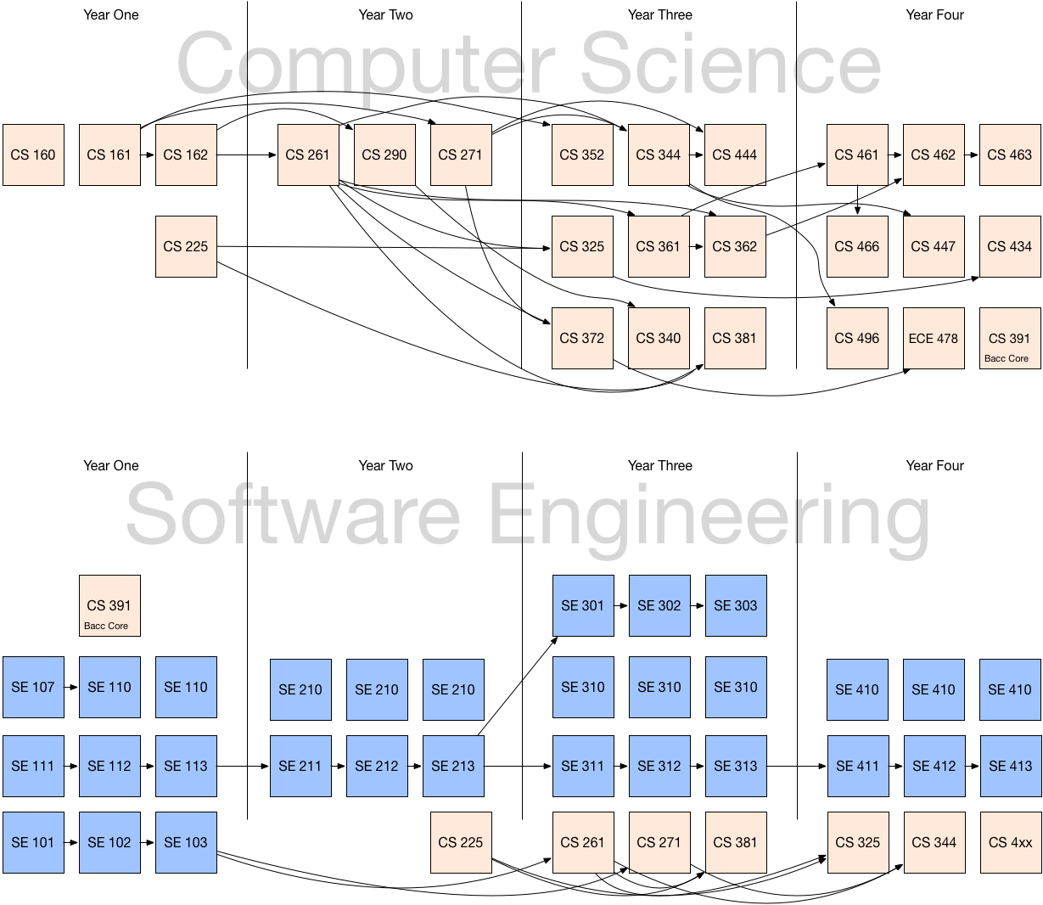

Figure 2. OSU CS and proposed SE programs.

The SE program has different outcomes than CS, different courses, and different course sequences outside of the CS courses it employs. Using one CSSE designator for all CS and SE courses would raise the following issues:

* + As a first year student, is the intro sequence of the “CS” path of CSSE 160, 161 and 162, or the “SE” path of CSSE 111, 112 and 113 coupled with CSSE 101, 102 and 103?
  + As an “SE” student in CSSE, what is the explanation for not being able to take the large number of CSSE courses? Is there any other program at OSU or at other institutions that has such significant exclusions between two large sets of courses within one designator?

See *Impacts*, below, for further illustration on the distinguishing factors of SE that cannot be replicated with courses in the CS and ECE programs.

Accountability

* What is the academic College of the designator?

The SE designator resides with the College of Engineering. Each program in the OSU College of Engineering has its own designator.

* Who is responsible for administering courses in the designator, e.g. scheduling and catalog updates. Who are the faculty contact persons?

The OSU-Cascades faculty and staff shall administer SE courses. The faculty contacts are Yong Bakos ([yong.bakos@osucascades.edu](mailto:yong.bakos@osucascades.edu)) and Dr. Marc Rubin ([marc.rubin@osucascades.edu](mailto:marc.rubin@osucascades.edu)).

* Who is responsible for consistency and outcome assessment for courses in the designator?

OSU-Cascades faculty and staff shall be responsible for consistency and outcome assessment for SE courses. Program assessments will be guided by ABET accreditation requirements.

* Which units get credit for the SCH generated by courses in the subject code?

The unit offering the SE course shall receive the SCH generated by courses in the subject code.

* Who is responsible for communicating information about the new designator to stakeholders, including advisors, Admissions, and students?

OSU-Cascades faculty and staff shall be responsible for communicating information about the SE designator to all stakeholders.

Impacts

* Will courses in the new designator duplicate or compete with existing ones?

Courses in the SE designator stand apart from, rather than compete with, existing courses in the computer science curriculum. While similar in nature to some computer science courses, the pre-requisites, course sequences, learning outcomes, course content, and pedagogy of the SE courses do not duplicate nor compete with existing courses. The Software Engineering curriculum differs from CS in its program learning outcomes, accreditation standards (but still ABET), and body of knowledge (IEEE SWEBOK). It stands apart from CS as other institutions have done (this isn't something radical), has a completely different curriculum design and pre-requisite structure, does not accommodate frictionless transfer between CS and SE as options/tracks do within CS itself, provides a minor that can stand apart from CS, and, symbolizes the very real difference between software engineering and computer science programs.

ECE Focus Areas do not, and should not, include software engineering. Software engineering is not a subset of Electrical and Computer Engineering. Does it include software? Yes. But it also includes electrical engineering, and physics. Clearly, these are other programs.

Pre-engineering course sequences are different.

* Are there expected cross-listings or curricular equivalencies?

There shall be no expected cross-listings for SE courses. OSU-Cascades plans to accept CS 160, 161 and 162 courses as curricular equivalencies for SE 101, 102 and 103. While these courses have different learning outcomes, we feel that students with a grade of B or better in the introductory computer science sequence shall receive credit for SE 101 – 103. In addition, this enables CS 160 – 162 course credits taken at Oregon community colleges to transfer to the proposed software engineering program at OSU-Cascades.

* How will the new designator affect transfer credits?

OSU-Cascades faculty and staff shall define articulation of transfer credits from related academic programs, such as computer science, information systems and software engineering. Specifically, credits from OSU or Oregon community college courses CS 160, 161 and 162 may be transferred to specific SE courses.

* Will any previous existing designators expire as the new one appears?

No existing designators shall expire because of the new SE designator.

* How will the new designator benefit students?

The new designator clearly distinguishes the courses in the BS Software Engineering degree program. For more information about this new program, please contact Yong Bakos ([yong.bakos@osucascades.edu](mailto:yong.bakos@osucascades.edu)) or see [Category I proposal 101368](https://secure.oregonstate.edu/ap/cps/proposals/view/101368).